**FileSystem Hierarchy Standard**

The **Linux FileSystem Hierarchy Standard (FHS)** defines the directory structure and contents in Unix-like operating systems. It is maintained by the **Linux Foundation** and serves as a guide to help maintain consistency across different distributions of Linux.

In Linux, **all files and directories exist under the root directory /**, even if they are stored on different physical or virtual devices. Some directories may be present only if certain subsystems are installed, but most are common across all UNIX and Linux systems.

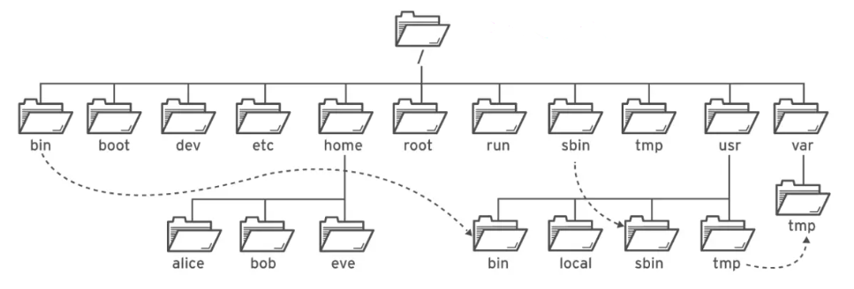

**Main Directories in FHS**

**1. / (Root Directory)**

* The top-level directory.
* All other directories and files are contained under this root.
* Even files from other drives are mounted under this hierarchy.

**2. /bin (Essential User Binaries)**

* Contains essential command binaries needed for single-user mode.
* Examples:
  + ls – List directory contents
  + cp – Copy files and directories
  + cat – Concatenate and display file contents

**3. /boot**

* Contains files needed to boot the system.
* Includes:
  + vmlinuz – Linux kernel
  + GRUB bootloader files
  + Initial RAM disk images

**4. /dev (Device Files)**

* Represents hardware devices as files.
* Examples:
  + /dev/sda – First hard drive
  + /dev/zero – Infinite stream of zero bytes

**5. /etc (Configuration Files)**

* Central control point of the system.
* Holds system-wide configuration files.
* Used for managing services and system behavior.

**6. /home (User Home Directories)**

* Each user has a personal directory under /home.
* Contains personal files, settings, and documents.

**7. /lib (Shared Libraries)**

* Houses libraries required by binaries in /bin and /sbin.
* Acts like a toolbox of reusable code.

**8. /media and /mnt (Mount Points)**

* /media: Automatically mounted removable media (e.g., USB drives).
* /mnt: Used for manually mounting temporary filesystems (e.g., network drives, ISO files).

**9. /opt (Optional Software Packages)**

* Used for installing third-party software.
* Keeps additional software organized and separate from system files.

**10. /sbin (System Binaries)**

* Similar to /bin, but contains tools for system administration.
* Examples:
  + iptables – Firewall configuration
  + fdisk – Disk partitioning

**11. /usr (User Programs and Data)**

* One of the largest directories.
* Contains user utilities, applications, libraries, and documentation.
* Not essential for system boot, but critical for user-level operations.

**12. /var (Variable Data)**

* Contains files that are expected to grow over time.
* Examples:
  + /var/log – System log files
  + /var/spool – Print queues and mail spools

**13. /srv (Service Data)**

* Holds site-specific data provided by services.
* Examples:
  + /srv/www – Web server data
  + /srv/ftp – FTP server files
  + /srv/cvs – CVS repositories

**14. /tmp (Temporary Files)**

* Temporary files created by system and users.
* Files are usually deleted at boot.
* May have size and security restrictions.

**15. /proc (Process and Kernel Info)**

* Virtual filesystem that contains runtime system information.
* Examples:
  + /proc/{pid} – Info about a specific process
  + /proc/uptime – System uptime